Ideation Phase
Brainstorm & Idea Prioritization

Date | 27-11-2025
Team ID
Project Name | Flight Booking System
Maximum Marks | 4 Marks

Problem Statement
To define the core problems faced by passengers, airlines, and travel admins in searching, selecting, and booking domestic or international flights, and use those insights to guide the development of Flight Booking System.
Step-1: Team Gathering, Collaboration and Select the Problem Statement
Before You Collaborate
A short preparation phase helps the team align on the purpose of the project.
Each team member should understand the common issues faced by travelers, airline staff, and booking agents while handling flight searches and ticket booking.
Team Gathering
- Bring all team members together to discuss the challenges in the current flight booking process.
- Share individual observations, research insights, and user pain points faced during travel planning.
- Ensure every participant contributes their viewpoint without judgment.
- Encourage open discussion to deeply understand real-life flight search and ticketing issues.
Discussion Highlights
During collaboration, the team identified recurring problems:
- Travelers struggle to find the right flights that match their destination, dates, and budget.
- Flight booking platforms show too many options without proper filters, causing confusion.
- Price variations between airlines make comparisons difficult.
- Ticket booking involves complex forms (passenger details, seat selection).
- Many airline systems lack a unified way to manage bookings and flight data.
- Users often face issues such as slow search results or outdated flight availability.

Step-2: Brainstorm, Idea Listing and Grouping
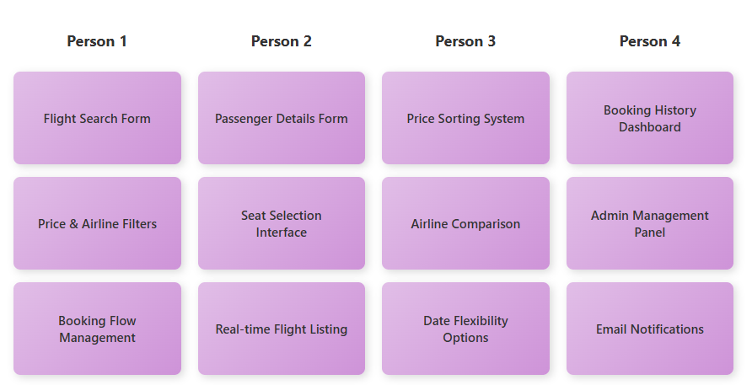
Brainstorm Ideas
- Complex flight search (From, To, Dates, Passengers)
- Real-time flight listing
- Price and airline filters
- Seat selection
- Passenger details form
- Ticket confirmation & invoice
- User login/signup
- Booking history
- Cancel or modify booking
- Integration with 3rd-party flight APIs
- Admin flight management panel
- Notifications & email confirmation
Team Inputs
P1: Flight search, filters, booking flow
P2: Passenger form, seat selection
P3: Price sorting, airline sorting
P4: Booking history, admin panel

Grouped Ideas
Passenger:
- Search flights
- Apply filters (price, airline, time)
- Select flights
- Add passenger details
- Seat selection
- Booking confirmation
- View booking history
Admin:
- Manage flights
- Update schedules
- View all bookings
Future:
- Live flight tracking
- Loyalty points
- Multi-city flight booking
Step-3: Idea Prioritization

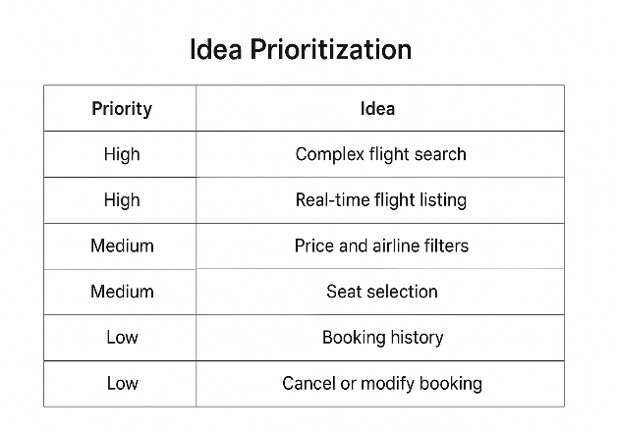

STEP 4: IMPLEMENTATION ROADMAP AND CONCLUSION
Implementation Plan
Based on our prioritization, we have created a phased implementation roadmap:
Phase 1: MVP Development
- User registration and authentication
- Flight search with filters (date, price, airline)
- Real-time flight listing
- Seat selection interface
- Passenger details form
- Booking confirmation and tickets
- Email/SMS notifications
Phase 2: Enhancement
- Booking history and management
- Cancel/modify booking feature
- Price comparison tools
- Payment gateway integration
- Admin dashboard for flight management
- Improved search filters
Phase 3: Advanced Features
- Multi-city flight booking
- Loyalty points program
- Live flight tracking
- Mobile app (iOS/Android)
- AI-based price predictions
- Group booking feature
Technology Stack
Frontend:
- HTML, CSS, JavaScript
- React.js
- Bootstrap
Backend:
- Node.js with Express.js
- RESTful API
Database:
- MongoDB
Additional Tools:
- Third-party Flight APIs (Amadeus/Skyscanner)
- Stripe/PayPal for payments
- Twilio for SMS notifications
- SendGrid for emails
- JWT for authentication
Conclusion
The Flight Booking System addresses critical challenges in flight search and booking processes. Through systematic brainstorming and prioritization, we identified 12 potential features and selected 7 high-priority features for the MVP.
Our phased implementation approach ensures we deliver core functionality quickly while planning for future enhancements. The system will benefit travelers through easy flight comparison, airlines through increased bookings, and admins through efficient management tools.

